hate=normal

1 run......

training 1 epoch...

26.59053349494934 seconds used......

1 training finished! average train loss: 0.9952238250304671

evaluating...

Confusion matrix, without normalization

[[ 320 55 398]

[ 82 80 268]

[ 196 58 2075]]

Normalized confusion matrix

[[0.41397154 0.07115136 0.5148771 ]

[0.19069767 0.18604651 0.62325581]

[0.08415629 0.02490339 0.89094032]]

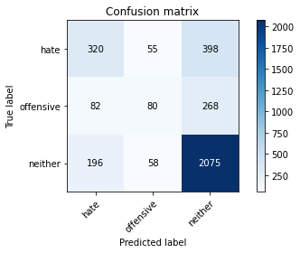

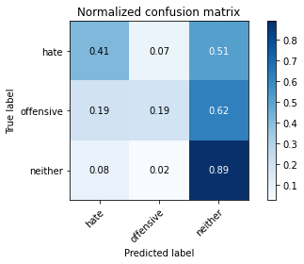

precision recall f1-score support

hate 0.54 0.41 0.47 773

offensive 0.41 0.19 0.26 430

neither 0.76 0.89 0.82 2329

accuracy 0.70 3532

macro avg 0.57 0.50 0.51 3532

weighted avg 0.67 0.70 0.67 3532

average eval_loss: 0.7498699029286703, accuracy: 0.700736126840317

training 2 epoch...

26.49464750289917 seconds used......

2 training finished! average train loss: 0.7066929423633743

evaluating...

Confusion matrix, without normalization

[[ 381 81 311]

[ 112 145 173]

[ 233 135 1961]]

Normalized confusion matrix

[[0.49288486 0.10478655 0.40232859]

[0.26046512 0.3372093 0.40232558]

[0.10004294 0.05796479 0.84199227]]

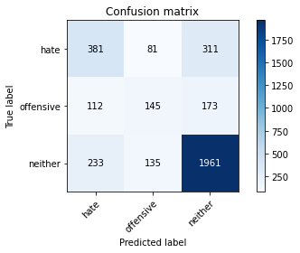

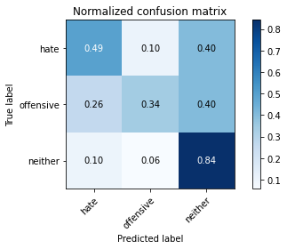

precision recall f1-score support

hate 0.52 0.49 0.51 773

offensive 0.40 0.34 0.37 430

neither 0.80 0.84 0.82 2329

accuracy 0.70 3532

macro avg 0.58 0.56 0.57 3532

weighted avg 0.69 0.70 0.70 3532

average eval_loss: 0.6973141238177564, accuracy: 0.7041336353340883

training 3 epoch...

26.52600407600403 seconds used......

3 training finished! average train loss: 0.47969022732885447

evaluating...

Confusion matrix, without normalization

[[ 373 30 370]

[ 146 87 197]

[ 184 47 2098]]

Normalized confusion matrix

[[0.48253558 0.03880983 0.47865459]

[0.33953488 0.20232558 0.45813953]

[0.07900386 0.02018033 0.9008158 ]]

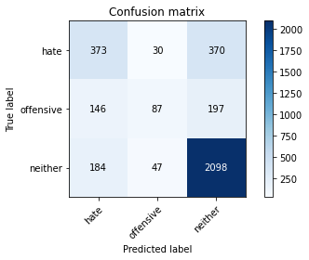

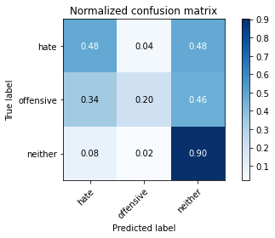

precision recall f1-score support

hate 0.53 0.48 0.51 773

offensive 0.53 0.20 0.29 430

neither 0.79 0.90 0.84 2329

accuracy 0.72 3532

macro avg 0.62 0.53 0.55 3532

weighted avg 0.70 0.72 0.70 3532

average eval_loss: 0.7707343476977052, accuracy: 0.7242355605889015

training 4 epoch...

26.539687156677246 seconds used......

4 training finished! average train loss: 0.26221198306473736

evaluating...

Confusion matrix, without normalization

[[ 413 100 260]

[ 111 175 144]

[ 264 185 1880]]

Normalized confusion matrix

[[0.53428202 0.12936611 0.33635188]

[0.25813953 0.40697674 0.33488372]

[0.11335337 0.07943323 0.8072134 ]]

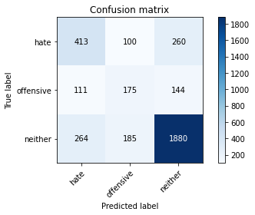

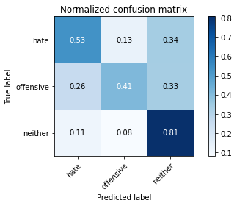

precision recall f1-score support

hate 0.52 0.53 0.53 773

offensive 0.38 0.41 0.39 430

neither 0.82 0.81 0.82 2329

accuracy 0.70 3532

macro avg 0.58 0.58 0.58 3532

weighted avg 0.70 0.70 0.70 3532

average eval_loss: 0.8710944836927672, accuracy: 0.6987542468856173

training 5 epoch...

26.418899536132812 seconds used......

5 training finished! average train loss: 0.11760701254174552

evaluating...

Confusion matrix, without normalization

[[ 410 78 285]

[ 122 161 147]

[ 233 156 1940]]

Normalized confusion matrix

[[0.53040103 0.10090556 0.3686934 ]

[0.28372093 0.3744186 0.34186047]

[0.10004294 0.06698154 0.83297553]]

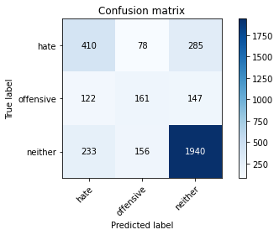

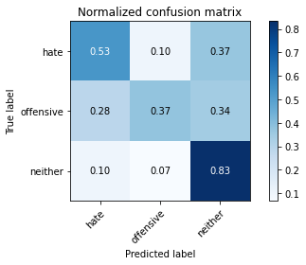

precision recall f1-score support

hate 0.54 0.53 0.53 773

offensive 0.41 0.37 0.39 430

neither 0.82 0.83 0.83 2329

accuracy 0.71 3532

macro avg 0.59 0.58 0.58 3532

weighted avg 0.71 0.71 0.71 3532

average eval_loss: 1.04168934412932, accuracy: 0.7109286523216308

training 6 epoch...

26.44261646270752 seconds used......

6 training finished! average train loss: 0.04406391917590929

evaluating...

Confusion matrix, without normalization

[[ 421 96 256]

[ 127 179 124]

[ 268 217 1844]]

Normalized confusion matrix

[[0.54463131 0.12419146 0.33117723]

[0.29534884 0.41627907 0.28837209]

[0.11507085 0.09317304 0.79175612]]

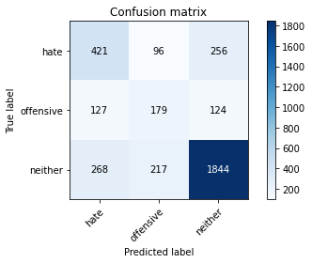

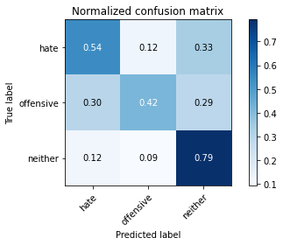

precision recall f1-score support

hate 0.52 0.54 0.53 773

offensive 0.36 0.42 0.39 430

neither 0.83 0.79 0.81 2329

accuracy 0.69 3532

macro avg 0.57 0.58 0.58 3532

weighted avg 0.70 0.69 0.70 3532

average eval_loss: 1.2559039942962302, accuracy: 0.6919592298980748

training 7 epoch...

26.480236053466797 seconds used......

7 training finished! average train loss: 0.038604781904723495

evaluating...

Confusion matrix, without normalization

[[ 432 128 213]

[ 133 196 101]

[ 330 275 1724]]

Normalized confusion matrix

[[0.55886158 0.16558862 0.27554981]

[0.30930233 0.45581395 0.23488372]

[0.14169171 0.11807643 0.74023186]]

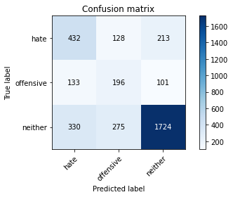

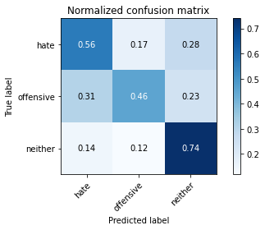

precision recall f1-score support

hate 0.48 0.56 0.52 773

offensive 0.33 0.46 0.38 430

neither 0.85 0.74 0.79 2329

accuracy 0.67 3532

macro avg 0.55 0.58 0.56 3532

weighted avg 0.70 0.67 0.68 3532

average eval_loss: 1.3791044155756633, accuracy: 0.665911664779162

training 8 epoch...

26.480998277664185 seconds used......

8 training finished! average train loss: 0.03584147740312962

evaluating...

Confusion matrix, without normalization

[[ 437 100 236]

[ 128 183 119]

[ 327 202 1800]]

Normalized confusion matrix

[[0.56532988 0.12936611 0.30530401]

[0.29767442 0.4255814 0.27674419]

[0.14040361 0.0867325 0.77286389]]

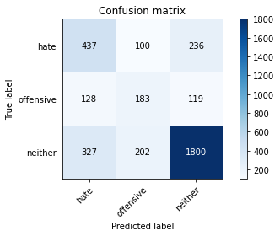

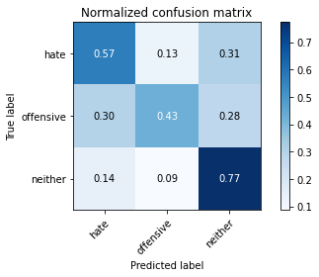

precision recall f1-score support

hate 0.49 0.57 0.52 773

offensive 0.38 0.43 0.40 430

neither 0.84 0.77 0.80 2329

accuracy 0.69 3532

macro avg 0.57 0.59 0.58 3532

weighted avg 0.70 0.69 0.69 3532

average eval_loss: 1.364820464603645, accuracy: 0.6851642129105323

training 9 epoch...

26.477867364883423 seconds used......

9 training finished! average train loss: 0.0054425683552193835

evaluating...

Confusion matrix, without normalization

[[ 393 127 253]

[ 107 200 123]

[ 264 237 1828]]

Normalized confusion matrix

[[0.5084088 0.16429495 0.32729625]

[0.24883721 0.46511628 0.28604651]

[0.11335337 0.10176041 0.78488622]]

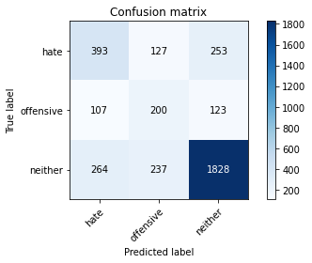

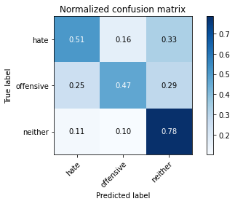

precision recall f1-score support

hate 0.51 0.51 0.51 773

offensive 0.35 0.47 0.40 430

neither 0.83 0.78 0.81 2329

accuracy 0.69 3532

macro avg 0.57 0.59 0.57 3532

weighted avg 0.70 0.69 0.69 3532

average eval_loss: 1.497897881740904, accuracy: 0.6854473386183465

training 10 epoch...

26.48439598083496 seconds used......

10 training finished! average train loss: 0.007043159167069997

evaluating...

Confusion matrix, without normalization

[[ 398 86 289]

[ 118 158 154]

[ 245 146 1938]]

Normalized confusion matrix

[[0.5148771 0.11125485 0.37386805]

[0.2744186 0.36744186 0.35813953]

[0.10519536 0.06268785 0.83211679]]

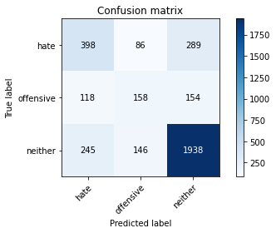

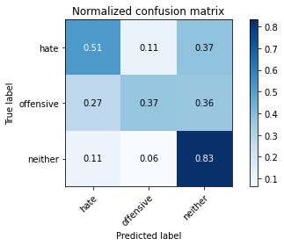

precision recall f1-score support

hate 0.52 0.51 0.52 773

offensive 0.41 0.37 0.39 430

neither 0.81 0.83 0.82 2329

accuracy 0.71 3532

macro avg 0.58 0.57 0.58 3532

weighted avg 0.70 0.71 0.70 3532

average eval_loss: 1.512084858397306, accuracy: 0.7061155152887882

2 run......

training 1 epoch...

26.490883111953735 seconds used......

1 training finished! average train loss: 0.9602789392366129

evaluating...

Confusion matrix, without normalization

[[ 362 97 314]

[ 104 143 183]

[ 238 151 1940]]

Normalized confusion matrix

[[0.4683053 0.12548512 0.40620957]

[0.24186047 0.33255814 0.4255814 ]

[0.10218978 0.06483469 0.83297553]]

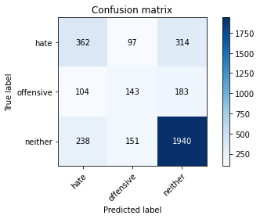

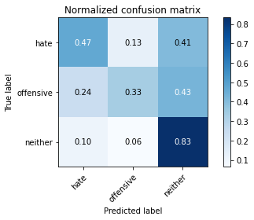

precision recall f1-score support

hate 0.51 0.47 0.49 773

offensive 0.37 0.33 0.35 430

neither 0.80 0.83 0.81 2329

accuracy 0.69 3532

macro avg 0.56 0.54 0.55 3532

weighted avg 0.68 0.69 0.69 3532

average eval_loss: 0.7423508596622338, accuracy: 0.692242355605889

training 2 epoch...

26.50376009941101 seconds used......

2 training finished! average train loss: 0.6820781200247652

evaluating...

Confusion matrix, without normalization

[[ 294 182 297]

[ 60 237 133]

[ 170 277 1882]]

Normalized confusion matrix

[[0.38033635 0.23544631 0.38421734]

[0.13953488 0.55116279 0.30930233]

[0.0729927 0.11893517 0.80807213]]

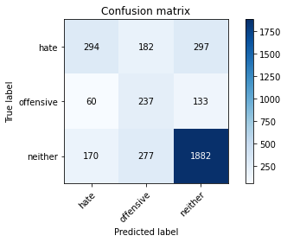

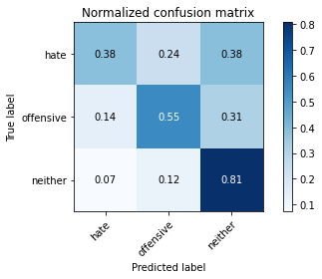

precision recall f1-score support

hate 0.56 0.38 0.45 773

offensive 0.34 0.55 0.42 430

neither 0.81 0.81 0.81 2329

accuracy 0.68 3532

macro avg 0.57 0.58 0.56 3532

weighted avg 0.70 0.68 0.69 3532

average eval_loss: 0.7504769600717361, accuracy: 0.6831823329558324

training 3 epoch...

26.509555339813232 seconds used......

3 training finished! average train loss: 0.46658139138975563

evaluating...

Confusion matrix, without normalization

[[ 326 104 343]

[ 79 168 183]

[ 177 157 1995]]

Normalized confusion matrix

[[0.42173351 0.13454075 0.44372574]

[0.18372093 0.39069767 0.4255814 ]

[0.07599828 0.06741091 0.85659081]]

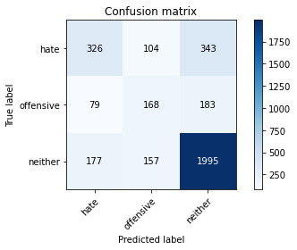

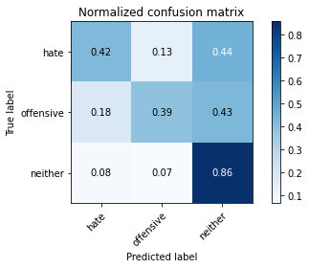

precision recall f1-score support

hate 0.56 0.42 0.48 773

offensive 0.39 0.39 0.39 430

neither 0.79 0.86 0.82 2329

accuracy 0.70 3532

macro avg 0.58 0.56 0.57 3532

weighted avg 0.69 0.70 0.70 3532

average eval_loss: 0.786056366764893, accuracy: 0.7046998867497168

training 4 epoch...

26.438592433929443 seconds used......

4 training finished! average train loss: 0.24432029057403698

evaluating...

Confusion matrix, without normalization

[[ 417 144 212]

[ 102 217 111]

[ 348 267 1714]]

Normalized confusion matrix

[[0.53945666 0.18628719 0.27425614]

[0.2372093 0.50465116 0.25813953]

[0.14942035 0.11464148 0.73593817]]

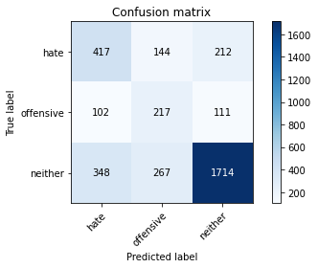

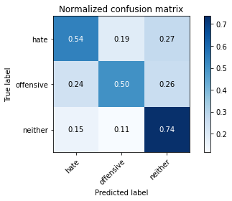

precision recall f1-score support

hate 0.48 0.54 0.51 773

offensive 0.35 0.50 0.41 430

neither 0.84 0.74 0.79 2329

accuracy 0.66 3532

macro avg 0.56 0.59 0.57 3532

weighted avg 0.70 0.66 0.68 3532

average eval_loss: 1.0274192248023837, accuracy: 0.6647791619479049

training 5 epoch...

26.571919918060303 seconds used......

5 training finished! average train loss: 0.10365323478575139

evaluating...

Confusion matrix, without normalization

[[ 418 101 254]

[ 118 178 134]

[ 335 176 1818]]

Normalized confusion matrix

[[0.54075032 0.13065977 0.32858991]

[0.2744186 0.41395349 0.31162791]

[0.14383856 0.07556891 0.78059253]]

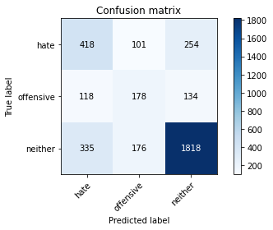

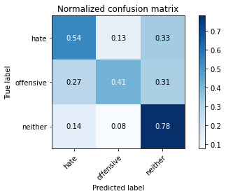

precision recall f1-score support

hate 0.48 0.54 0.51 773

offensive 0.39 0.41 0.40 430

neither 0.82 0.78 0.80 2329

accuracy 0.68 3532

macro avg 0.57 0.58 0.57 3532

weighted avg 0.70 0.68 0.69 3532

average eval_loss: 1.135503838038714, accuracy: 0.6834654586636466

training 6 epoch...

26.58755397796631 seconds used......

6 training finished! average train loss: 0.037969003410955125

evaluating...

Confusion matrix, without normalization

[[ 393 140 240]

[ 101 213 116]

[ 298 282 1749]]

Normalized confusion matrix

[[0.5084088 0.18111255 0.31047865]

[0.23488372 0.49534884 0.26976744]

[0.12795191 0.12108201 0.75096608]]

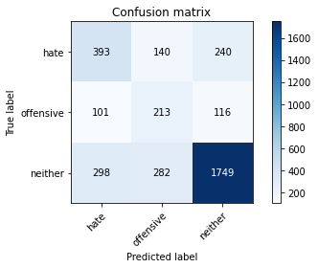

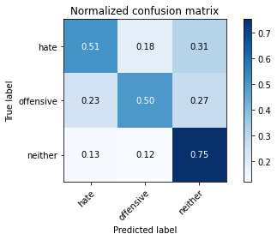

precision recall f1-score support

hate 0.50 0.51 0.50 773

offensive 0.34 0.50 0.40 430

neither 0.83 0.75 0.79 2329

accuracy 0.67 3532

macro avg 0.55 0.58 0.56 3532

weighted avg 0.70 0.67 0.68 3532

average eval_loss: 1.392555322014006, accuracy: 0.6667610419026048

training 7 epoch...

26.475245475769043 seconds used......

7 training finished! average train loss: 0.03347692108089926

evaluating...

Confusion matrix, without normalization

[[ 393 175 205]

[ 93 239 98]

[ 328 359 1642]]

Normalized confusion matrix

[[0.5084088 0.22639069 0.26520052]

[0.21627907 0.55581395 0.22790698]

[0.14083298 0.15414341 0.70502362]]

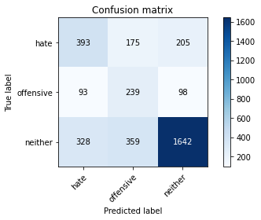

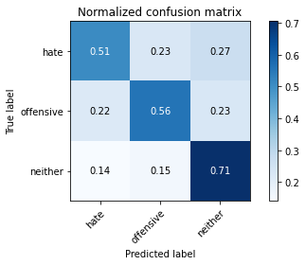

precision recall f1-score support

hate 0.48 0.51 0.50 773

offensive 0.31 0.56 0.40 430

neither 0.84 0.71 0.77 2329

accuracy 0.64 3532

macro avg 0.55 0.59 0.55 3532

weighted avg 0.70 0.64 0.66 3532

average eval_loss: 1.4929782525967743, accuracy: 0.6438278595696489

training 8 epoch...

26.44935393333435 seconds used......

8 training finished! average train loss: 0.01473216427856481

evaluating...

Confusion matrix, without normalization

[[ 368 116 289]

[ 103 172 155]

[ 267 147 1915]]

Normalized confusion matrix

[[0.47606727 0.15006468 0.37386805]

[0.23953488 0.4 0.36046512]

[0.11464148 0.06311722 0.82224131]]

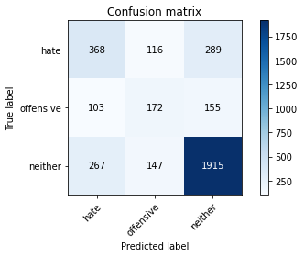

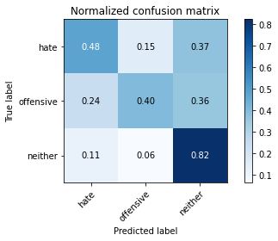

precision recall f1-score support

hate 0.50 0.48 0.49 773

offensive 0.40 0.40 0.40 430

neither 0.81 0.82 0.82 2329

accuracy 0.70 3532

macro avg 0.57 0.57 0.57 3532

weighted avg 0.69 0.70 0.69 3532

average eval_loss: 1.449751768103343, accuracy: 0.6950736126840317

training 9 epoch...

26.47655701637268 seconds used......

9 training finished! average train loss: 0.008685206176083097

evaluating...

Confusion matrix, without normalization

[[ 390 165 218]

[ 98 220 112]

[ 346 281 1702]]

Normalized confusion matrix

[[0.50452781 0.21345408 0.28201811]

[0.22790698 0.51162791 0.26046512]

[0.14856161 0.12065264 0.73078574]]

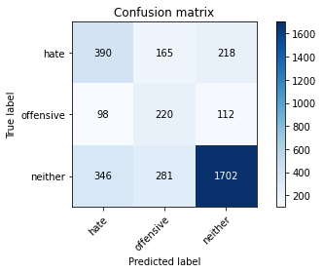

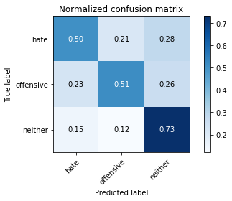

precision recall f1-score support

hate 0.47 0.50 0.49 773

offensive 0.33 0.51 0.40 430

neither 0.84 0.73 0.78 2329

accuracy 0.65 3532

macro avg 0.55 0.58 0.56 3532

weighted avg 0.69 0.65 0.67 3532

average eval_loss: 1.6641789652449264, accuracy: 0.6545866364665912

training 10 epoch...

26.496143579483032 seconds used......

10 training finished! average train loss: 0.021423930307398278

evaluating...

Confusion matrix, without normalization

[[ 358 141 274]

[ 84 215 131]

[ 279 213 1837]]

Normalized confusion matrix

[[0.46313066 0.18240621 0.35446313]

[0.19534884 0.5 0.30465116]

[0.1197939 0.09145556 0.78875054]]

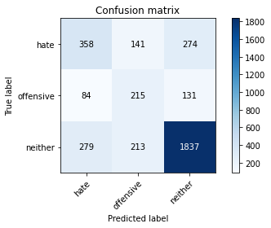

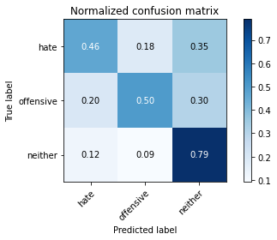

precision recall f1-score support

hate 0.50 0.46 0.48 773

offensive 0.38 0.50 0.43 430

neither 0.82 0.79 0.80 2329

accuracy 0.68 3532

macro avg 0.56 0.58 0.57 3532

weighted avg 0.69 0.68 0.69 3532

average eval_loss: 1.5568283264246363, accuracy: 0.6823329558323896

3 run......

training 1 epoch...

26.499834299087524 seconds used......

1 training finished! average train loss: 1.0173637525123709

evaluating...

Confusion matrix, without normalization

[[ 406 69 298]

[ 118 117 195]

[ 306 89 1934]]

Normalized confusion matrix

[[0.52522639 0.08926261 0.385511 ]

[0.2744186 0.27209302 0.45348837]

[0.13138686 0.03821383 0.83039931]]

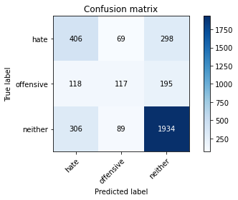

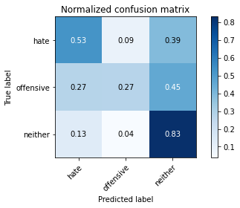

precision recall f1-score support

hate 0.49 0.53 0.51 773

offensive 0.43 0.27 0.33 430

neither 0.80 0.83 0.81 2329

accuracy 0.70 3532

macro avg 0.57 0.54 0.55 3532

weighted avg 0.68 0.70 0.69 3532

average eval_loss: 0.751830908538258, accuracy: 0.6956398640996603

training 2 epoch...

26.39595627784729 seconds used......

2 training finished! average train loss: 0.7150313628508764

evaluating...

Confusion matrix, without normalization

[[ 351 140 282]

[ 75 211 144]

[ 222 219 1888]]

Normalized confusion matrix

[[0.45407503 0.18111255 0.36481242]

[0.1744186 0.49069767 0.33488372]

[0.09531988 0.09403177 0.81064835]]

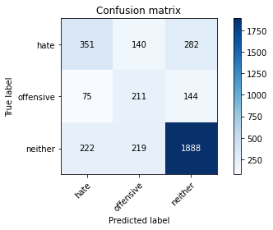

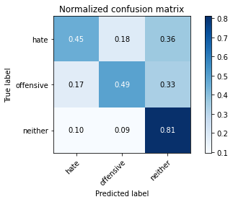

precision recall f1-score support

hate 0.54 0.45 0.49 773

offensive 0.37 0.49 0.42 430

neither 0.82 0.81 0.81 2329

accuracy 0.69 3532

macro avg 0.58 0.59 0.58 3532

weighted avg 0.70 0.69 0.70 3532

average eval_loss: 0.7296332893735271, accuracy: 0.6936579841449604

training 3 epoch...

26.44335389137268 seconds used......

3 training finished! average train loss: 0.4804538412786582

evaluating...

Confusion matrix, without normalization

[[ 438 126 209]

[ 108 216 106]

[ 364 262 1703]]

Normalized confusion matrix

[[0.56662354 0.16300129 0.27037516]

[0.25116279 0.50232558 0.24651163]

[0.15629025 0.11249463 0.73121511]]

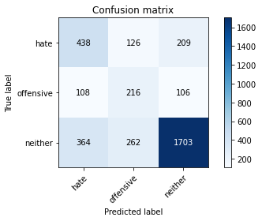

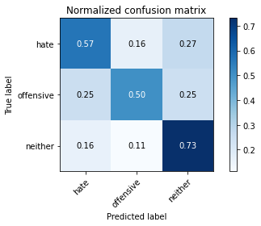

precision recall f1-score support

hate 0.48 0.57 0.52 773

offensive 0.36 0.50 0.42 430

neither 0.84 0.73 0.78 2329

accuracy 0.67 3532

macro avg 0.56 0.60 0.57 3532

weighted avg 0.71 0.67 0.68 3532

average eval_loss: 0.8519562993009212, accuracy: 0.6673272933182333

training 4 epoch...

26.451552629470825 seconds used......

4 training finished! average train loss: 0.267627828014905

evaluating...

Confusion matrix, without normalization

[[ 438 112 223]

[ 118 196 116]

[ 338 262 1729]]

Normalized confusion matrix

[[0.56662354 0.14489004 0.28848642]

[0.2744186 0.45581395 0.26976744]

[0.14512666 0.11249463 0.7423787 ]]

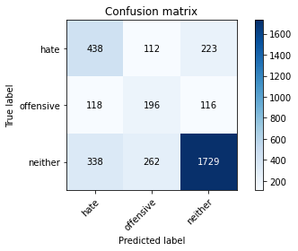

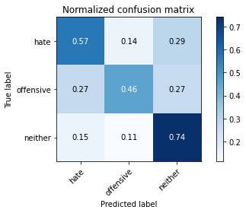

precision recall f1-score support

hate 0.49 0.57 0.53 773

offensive 0.34 0.46 0.39 430

neither 0.84 0.74 0.79 2329

accuracy 0.67 3532

macro avg 0.56 0.59 0.57 3532

weighted avg 0.70 0.67 0.68 3532

average eval_loss: 0.9541996586120735, accuracy: 0.669026047565119

training 5 epoch...

26.461224794387817 seconds used......

5 training finished! average train loss: 0.13415727575364358

evaluating...

Confusion matrix, without normalization

[[ 372 193 208]

[ 76 249 105]

[ 255 397 1677]]

Normalized confusion matrix

[[0.48124191 0.24967658 0.2690815 ]

[0.17674419 0.57906977 0.24418605]

[0.10948905 0.17045942 0.72005152]]

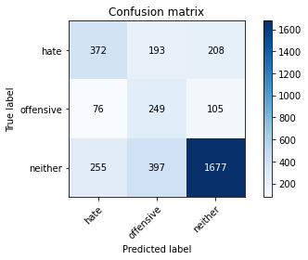

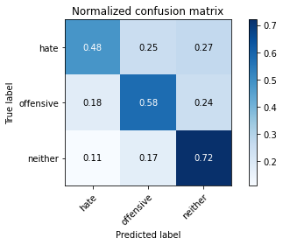

precision recall f1-score support

hate 0.53 0.48 0.50 773

offensive 0.30 0.58 0.39 430

neither 0.84 0.72 0.78 2329

accuracy 0.65 3532

macro avg 0.56 0.59 0.56 3532

weighted avg 0.71 0.65 0.67 3532

average eval_loss: 1.1930607303892826, accuracy: 0.6506228765571914

training 6 epoch...

26.486087322235107 seconds used......

6 training finished! average train loss: 0.047864133307217234

evaluating...

Confusion matrix, without normalization

[[ 402 180 191]

[ 88 256 86]

[ 317 363 1649]]

Normalized confusion matrix

[[0.52005175 0.23285899 0.24708926]

[0.20465116 0.59534884 0.2 ]

[0.13610992 0.15586088 0.7080292 ]]

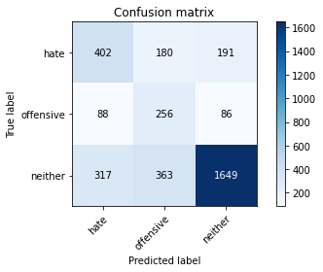

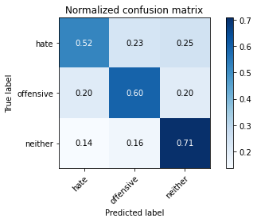

precision recall f1-score support

hate 0.50 0.52 0.51 773

offensive 0.32 0.60 0.42 430

neither 0.86 0.71 0.78 2329

accuracy 0.65 3532

macro avg 0.56 0.61 0.57 3532

weighted avg 0.71 0.65 0.67 3532

average eval_loss: 1.4437626949643012, accuracy: 0.6531710079275198

training 7 epoch...

26.454517602920532 seconds used......

7 training finished! average train loss: 0.025629704355892232

evaluating...

Confusion matrix, without normalization

[[ 327 151 295]

[ 72 218 140]

[ 196 243 1890]]

Normalized confusion matrix

[[0.42302717 0.19534282 0.38163001]

[0.16744186 0.50697674 0.3255814 ]

[0.08415629 0.10433663 0.81150708]]

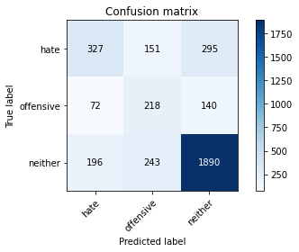

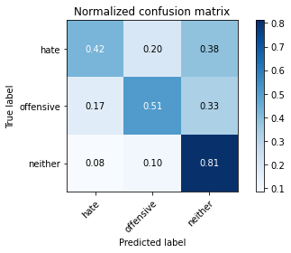

precision recall f1-score support

hate 0.55 0.42 0.48 773

offensive 0.36 0.51 0.42 430

neither 0.81 0.81 0.81 2329

accuracy 0.69 3532

macro avg 0.57 0.58 0.57 3532

weighted avg 0.70 0.69 0.69 3532

average eval_loss: 1.3803184624277265, accuracy: 0.6894110985277463

training 8 epoch...

26.465653657913208 seconds used......

8 training finished! average train loss: 0.00891507101144217

evaluating...

Confusion matrix, without normalization

[[ 412 116 245]

[ 106 198 126]

[ 290 233 1806]]

Normalized confusion matrix

[[0.53298836 0.15006468 0.31694696]

[0.24651163 0.46046512 0.29302326]

[0.12451696 0.10004294 0.7754401 ]]

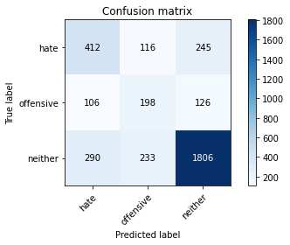

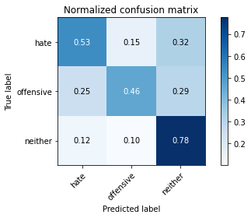

precision recall f1-score support

hate 0.51 0.53 0.52 773

offensive 0.36 0.46 0.41 430

neither 0.83 0.78 0.80 2329

accuracy 0.68 3532

macro avg 0.57 0.59 0.58 3532

weighted avg 0.70 0.68 0.69 3532

average eval_loss: 1.5192098558833034, accuracy: 0.6840317100792752

training 9 epoch...

26.466728687286377 seconds used......

9 training finished! average train loss: 0.005073612494657829

evaluating...

Confusion matrix, without normalization

[[ 366 128 279]

[ 85 208 137]

[ 222 231 1876]]

Normalized confusion matrix

[[0.47347995 0.16558862 0.36093144]

[0.19767442 0.48372093 0.31860465]

[0.09531988 0.0991842 0.80549592]]

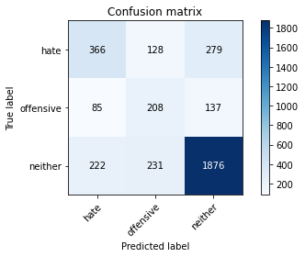

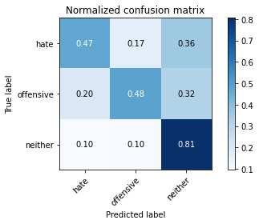

precision recall f1-score support

hate 0.54 0.47 0.51 773

offensive 0.37 0.48 0.42 430

neither 0.82 0.81 0.81 2329

accuracy 0.69 3532

macro avg 0.58 0.59 0.58 3532

weighted avg 0.70 0.69 0.70 3532

average eval_loss: 1.6014362943837535, accuracy: 0.6936579841449604

training 10 epoch...

26.43528699874878 seconds used......

10 training finished! average train loss: 0.003549722453017774

evaluating...

Confusion matrix, without normalization

[[ 355 114 304]

[ 94 190 146]

[ 190 213 1926]]

Normalized confusion matrix

[[0.45924968 0.14747736 0.39327296]

[0.21860465 0.44186047 0.33953488]

[0.08158008 0.09145556 0.82696436]]

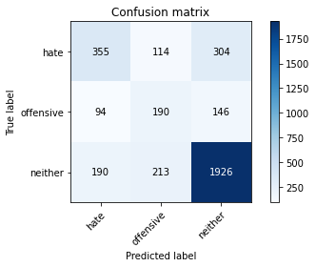

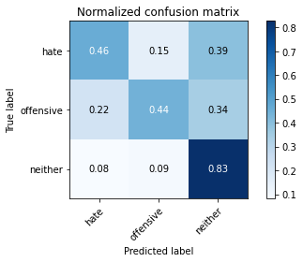

precision recall f1-score support

hate 0.56 0.46 0.50 773

offensive 0.37 0.44 0.40 430

neither 0.81 0.83 0.82 2329

accuracy 0.70 3532

macro avg 0.58 0.58 0.57 3532

weighted avg 0.70 0.70 0.70 3532

average eval_loss: 1.6258984737277116, accuracy: 0.6996036240090601

4 run......

training 1 epoch...

26.547747373580933 seconds used......

1 training finished! average train loss: 0.9875059982433039

evaluating...

Confusion matrix, without normalization

[[ 606 76 91]

[ 240 125 65]

[ 860 253 1216]]

Normalized confusion matrix

[[0.7839586 0.09831824 0.11772316]

[0.55813953 0.29069767 0.15116279]

[0.36925719 0.10863031 0.52211249]]

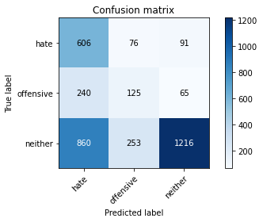

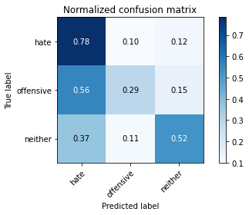

precision recall f1-score support

hate 0.36 0.78 0.49 773

offensive 0.28 0.29 0.28 430

neither 0.89 0.52 0.66 2329

accuracy 0.55 3532

macro avg 0.51 0.53 0.48 3532

weighted avg 0.70 0.55 0.57 3532

average eval_loss: 0.9985330337184971, accuracy: 0.5512457531143827

training 2 epoch...

26.49946880340576 seconds used......

2 training finished! average train loss: 0.709433381610057

evaluating...

Confusion matrix, without normalization

[[ 361 56 356]

[ 106 138 186]

[ 175 93 2061]]

Normalized confusion matrix

[[0.46701164 0.07244502 0.46054334]

[0.24651163 0.32093023 0.43255814]

[0.07513954 0.0399313 0.88492915]]

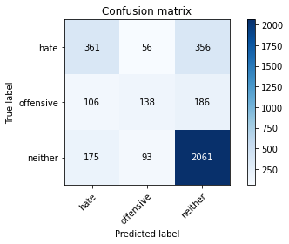

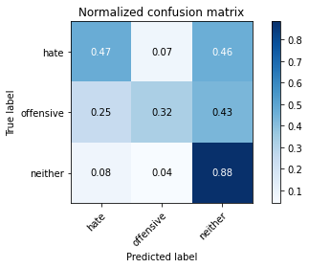

precision recall f1-score support

hate 0.56 0.47 0.51 773

offensive 0.48 0.32 0.38 430

neither 0.79 0.88 0.84 2329

accuracy 0.72 3532

macro avg 0.61 0.56 0.58 3532

weighted avg 0.70 0.72 0.71 3532

average eval_loss: 0.6829410729098455, accuracy: 0.72480181200453

training 3 epoch...

26.471585035324097 seconds used......

3 training finished! average train loss: 0.4727368821554324

evaluating...

Confusion matrix, without normalization

[[ 399 144 230]

[ 88 219 123]

[ 280 300 1749]]

Normalized confusion matrix

[[0.51617076 0.18628719 0.29754204]

[0.20465116 0.50930233 0.28604651]

[0.12022327 0.12881065 0.75096608]]

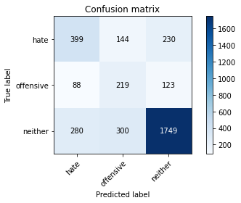

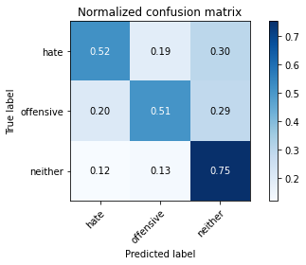

precision recall f1-score support

hate 0.52 0.52 0.52 773

offensive 0.33 0.51 0.40 430

neither 0.83 0.75 0.79 2329

accuracy 0.67 3532

macro avg 0.56 0.59 0.57 3532

weighted avg 0.70 0.67 0.68 3532

average eval_loss: 0.8042757263628103, accuracy: 0.670158550396376

training 4 epoch...

26.427058935165405 seconds used......

4 training finished! average train loss: 0.2605068623362219

evaluating...

Confusion matrix, without normalization

[[ 340 174 259]

[ 65 225 140]

[ 207 268 1854]]

Normalized confusion matrix

[[0.43984476 0.22509702 0.33505821]

[0.15116279 0.52325581 0.3255814 ]

[0.08887935 0.11507085 0.79604981]]

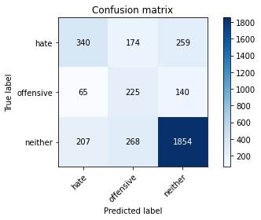

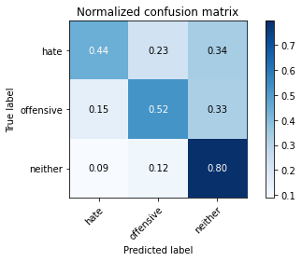

precision recall f1-score support

hate 0.56 0.44 0.49 773

offensive 0.34 0.52 0.41 430

neither 0.82 0.80 0.81 2329

accuracy 0.68 3532

macro avg 0.57 0.59 0.57 3532

weighted avg 0.71 0.68 0.69 3532

average eval_loss: 0.9244913369585566, accuracy: 0.684881087202718

training 5 epoch...

26.461081504821777 seconds used......

5 training finished! average train loss: 0.10642805891385411

evaluating...

Confusion matrix, without normalization

[[ 372 167 234]

[ 74 228 128]

[ 259 281 1789]]

Normalized confusion matrix

[[0.48124191 0.2160414 0.30271669]

[0.17209302 0.53023256 0.29767442]

[0.11120653 0.12065264 0.76814083]]

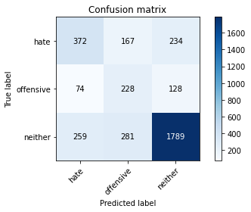

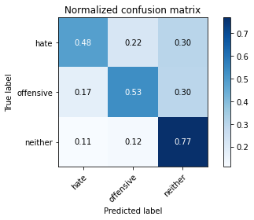

precision recall f1-score support

hate 0.53 0.48 0.50 773

offensive 0.34 0.53 0.41 430

neither 0.83 0.77 0.80 2329

accuracy 0.68 3532

macro avg 0.57 0.59 0.57 3532

weighted avg 0.70 0.68 0.69 3532

average eval_loss: 1.1801279921316157, accuracy: 0.6763873159682899

training 6 epoch...

26.425026178359985 seconds used......

6 training finished! average train loss: 0.037395656766260374

evaluating...

Confusion matrix, without normalization

[[ 432 111 230]

[ 110 187 133]

[ 311 238 1780]]

Normalized confusion matrix

[[0.55886158 0.14359638 0.29754204]

[0.25581395 0.43488372 0.30930233]

[0.13353371 0.10218978 0.76427651]]

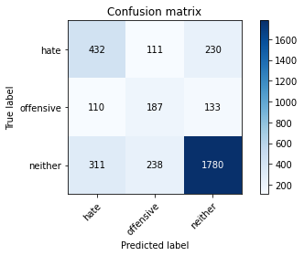

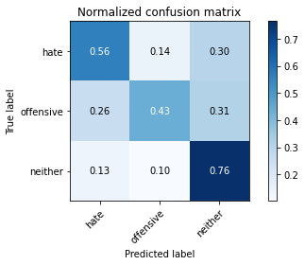

precision recall f1-score support

hate 0.51 0.56 0.53 773

offensive 0.35 0.43 0.39 430

neither 0.83 0.76 0.80 2329

accuracy 0.68 3532

macro avg 0.56 0.59 0.57 3532

weighted avg 0.70 0.68 0.69 3532

average eval_loss: 1.3629347961501213, accuracy: 0.6792185730464326

training 7 epoch...

26.483009338378906 seconds used......

7 training finished! average train loss: 0.025705989100970328

evaluating...

Confusion matrix, without normalization

[[ 309 166 298]

[ 64 230 136]

[ 159 269 1901]]

Normalized confusion matrix

[[0.39974127 0.21474774 0.385511 ]

[0.14883721 0.53488372 0.31627907]

[0.06826964 0.11550021 0.81623014]]

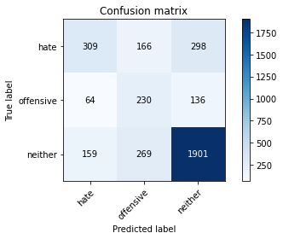

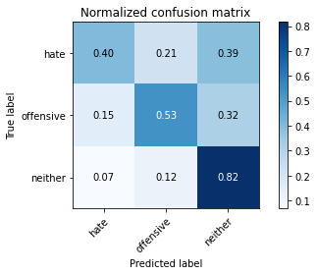

precision recall f1-score support

hate 0.58 0.40 0.47 773

offensive 0.35 0.53 0.42 430

neither 0.81 0.82 0.82 2329

accuracy 0.69 3532

macro avg 0.58 0.58 0.57 3532

weighted avg 0.71 0.69 0.69 3532

average eval_loss: 1.415976012999055, accuracy: 0.6908267270668177

training 8 epoch...

26.401400089263916 seconds used......

8 training finished! average train loss: 0.02125493194976383

evaluating...

Confusion matrix, without normalization

[[ 395 124 254]

[ 96 198 136]

[ 265 224 1840]]

Normalized confusion matrix

[[0.51099612 0.16041397 0.32858991]

[0.22325581 0.46046512 0.31627907]

[0.11378274 0.09617862 0.79003864]]

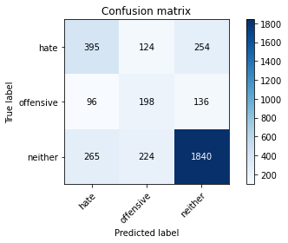

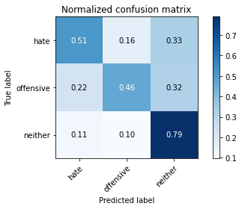

precision recall f1-score support

hate 0.52 0.51 0.52 773

offensive 0.36 0.46 0.41 430

neither 0.83 0.79 0.81 2329

accuracy 0.69 3532

macro avg 0.57 0.59 0.58 3532

weighted avg 0.70 0.69 0.69 3532

average eval_loss: 1.444416105747223, accuracy: 0.6888448471121178

training 9 epoch...

26.52144432067871 seconds used......

9 training finished! average train loss: 0.014370738164443002

evaluating...

Confusion matrix, without normalization

[[ 311 191 271]

[ 53 249 128]

[ 182 307 1840]]

Normalized confusion matrix

[[0.40232859 0.24708926 0.35058215]

[0.12325581 0.57906977 0.29767442]

[0.07814513 0.13181623 0.79003864]]

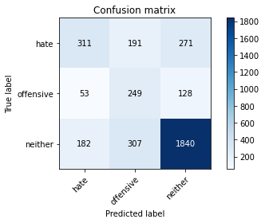

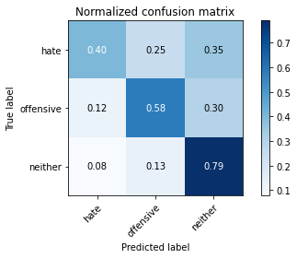

precision recall f1-score support

hate 0.57 0.40 0.47 773

offensive 0.33 0.58 0.42 430

neither 0.82 0.79 0.81 2329

accuracy 0.68 3532

macro avg 0.57 0.59 0.57 3532

weighted avg 0.71 0.68 0.69 3532

average eval_loss: 1.6367053941397343, accuracy: 0.6795016987542469

training 10 epoch...

26.44113302230835 seconds used......

10 training finished! average train loss: 0.01312126170266899

evaluating...

Confusion matrix, without normalization

[[ 400 105 268]

[ 99 190 141]

[ 263 191 1875]]

Normalized confusion matrix

[[0.51746442 0.13583441 0.34670116]

[0.23023256 0.44186047 0.32790698]

[0.112924 0.08200945 0.80506655]]

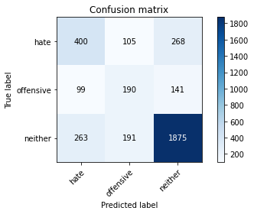

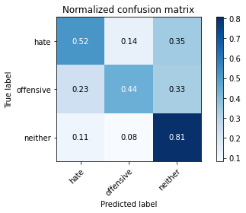

precision recall f1-score support

hate 0.52 0.52 0.52 773

offensive 0.39 0.44 0.41 430

neither 0.82 0.81 0.81 2329

accuracy 0.70 3532

macro avg 0.58 0.59 0.58 3532

weighted avg 0.70 0.70 0.70 3532

average eval_loss: 1.6213665101571946, accuracy: 0.6979048697621744

5 run......

training 1 epoch...

26.470804452896118 seconds used......

1 training finished! average train loss: 0.9992485112127136

evaluating...

Confusion matrix, without normalization

[[ 354 130 289]

[ 99 155 176]

[ 281 206 1842]]

Normalized confusion matrix

[[0.45795602 0.16817594 0.37386805]

[0.23023256 0.36046512 0.40930233]

[0.12065264 0.08844998 0.79089738]]

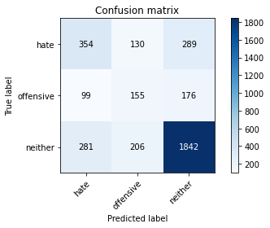

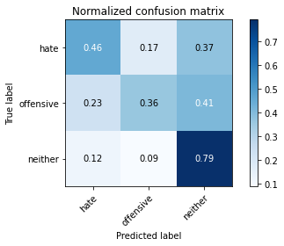

precision recall f1-score support

hate 0.48 0.46 0.47 773

offensive 0.32 0.36 0.34 430

neither 0.80 0.79 0.79 2329

accuracy 0.67 3532

macro avg 0.53 0.54 0.53 3532

weighted avg 0.67 0.67 0.67 3532

average eval_loss: 0.7923274966283033, accuracy: 0.6656285390713477

training 2 epoch...

26.41269063949585 seconds used......

2 training finished! average train loss: 0.7079762042883564

evaluating...

Confusion matrix, without normalization

[[ 401 62 310]

[ 127 153 150]

[ 214 127 1988]]

Normalized confusion matrix

[[0.51875809 0.08020699 0.40103493]

[0.29534884 0.35581395 0.34883721]

[0.09188493 0.05452984 0.85358523]]

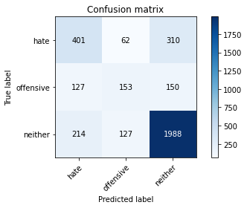

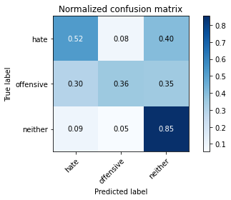

precision recall f1-score support

hate 0.54 0.52 0.53 773

offensive 0.45 0.36 0.40 430

neither 0.81 0.85 0.83 2329

accuracy 0.72 3532

macro avg 0.60 0.58 0.59 3532

weighted avg 0.71 0.72 0.71 3532

average eval_loss: 0.700014343706228, accuracy: 0.7197055492638732

training 3 epoch...

26.463192462921143 seconds used......

3 training finished! average train loss: 0.468886561691761

evaluating...

Confusion matrix, without normalization

[[ 294 113 366]

[ 58 179 193]

[ 137 125 2067]]

Normalized confusion matrix

[[0.38033635 0.1461837 0.47347995]

[0.13488372 0.41627907 0.44883721]

[0.05882353 0.0536711 0.88750537]]

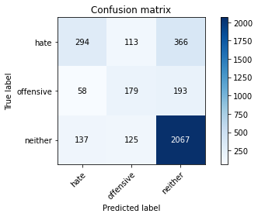

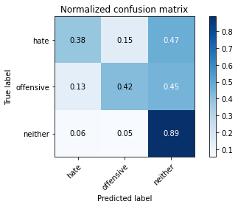

precision recall f1-score support

hate 0.60 0.38 0.47 773

offensive 0.43 0.42 0.42 430

neither 0.79 0.89 0.83 2329

accuracy 0.72 3532

macro avg 0.61 0.56 0.57 3532

weighted avg 0.70 0.72 0.70 3532

average eval_loss: 0.787075311198073, accuracy: 0.7191392978482446

training 4 epoch...

26.420213222503662 seconds used......

4 training finished! average train loss: 0.252313504132497

evaluating...

Confusion matrix, without normalization

[[ 289 147 337]

[ 46 216 168]

[ 114 173 2042]]

Normalized confusion matrix

[[0.37386805 0.19016818 0.43596378]

[0.10697674 0.50232558 0.39069767]

[0.04894805 0.07428081 0.87677115]]

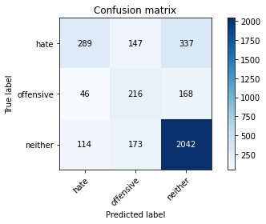

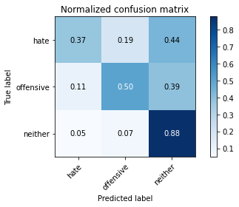

precision recall f1-score support

hate 0.64 0.37 0.47 773

offensive 0.40 0.50 0.45 430

neither 0.80 0.88 0.84 2329

accuracy 0.72 3532

macro avg 0.62 0.58 0.59 3532

weighted avg 0.72 0.72 0.71 3532

average eval_loss: 0.9274378176041915, accuracy: 0.7211211778029445

training 5 epoch...

26.49814009666443 seconds used......

5 training finished! average train loss: 0.1085410989163553

evaluating...

Confusion matrix, without normalization

[[ 366 167 240]

[ 77 239 114]

[ 228 316 1785]]

Normalized confusion matrix

[[0.47347995 0.2160414 0.31047865]

[0.17906977 0.55581395 0.26511628]

[0.09789609 0.13568055 0.76642336]]

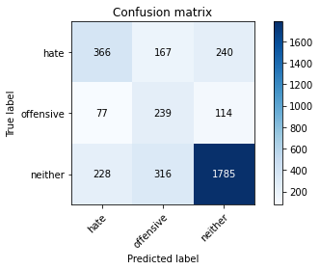

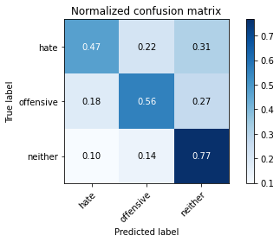

precision recall f1-score support

hate 0.55 0.47 0.51 773

offensive 0.33 0.56 0.41 430

neither 0.83 0.77 0.80 2329

accuracy 0.68 3532

macro avg 0.57 0.60 0.57 3532

weighted avg 0.71 0.68 0.69 3532

average eval_loss: 1.1701306425413842, accuracy: 0.6766704416761042

training 6 epoch...

26.42174530029297 seconds used......

6 training finished! average train loss: 0.03293869250474552

evaluating...

Confusion matrix, without normalization

[[ 387 144 242]

[ 80 229 121]

[ 227 295 1807]]

Normalized confusion matrix

[[0.50064683 0.18628719 0.31306598]

[0.18604651 0.53255814 0.28139535]

[0.09746672 0.1266638 0.77586947]]

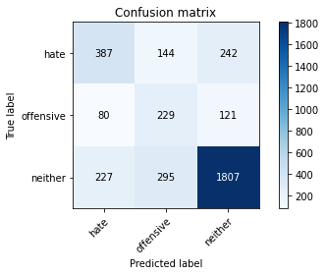

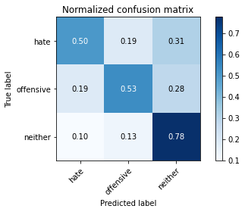

precision recall f1-score support

hate 0.56 0.50 0.53 773

offensive 0.34 0.53 0.42 430

neither 0.83 0.78 0.80 2329

accuracy 0.69 3532

macro avg 0.58 0.60 0.58 3532

weighted avg 0.71 0.69 0.70 3532

average eval_loss: 1.345830152432124, accuracy: 0.6860135900339751

training 7 epoch...

26.43395733833313 seconds used......

7 training finished! average train loss: 0.016987977139412098

evaluating...

Confusion matrix, without normalization

[[ 368 148 257]

[ 80 241 109]

[ 225 306 1798]]

Normalized confusion matrix

[[0.47606727 0.19146184 0.33247089]

[0.18604651 0.56046512 0.25348837]

[0.09660799 0.13138686 0.77200515]]

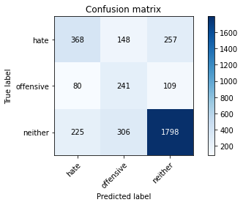

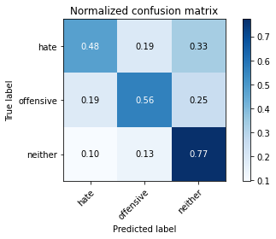

precision recall f1-score support

hate 0.55 0.48 0.51 773

offensive 0.35 0.56 0.43 430

neither 0.83 0.77 0.80 2329

accuracy 0.68 3532

macro avg 0.57 0.60 0.58 3532

weighted avg 0.71 0.68 0.69 3532

average eval_loss: 1.4763041595786304, accuracy: 0.6814835787089468

training 8 epoch...

26.45267915725708 seconds used......

8 training finished! average train loss: 0.0120732820017592

evaluating...

Confusion matrix, without normalization

[[ 402 137 234]

[ 100 220 110]

[ 273 294 1762]]

Normalized confusion matrix

[[0.52005175 0.17723157 0.30271669]

[0.23255814 0.51162791 0.25581395]

[0.11721769 0.12623444 0.75654787]]

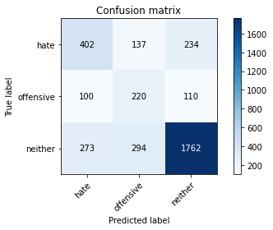

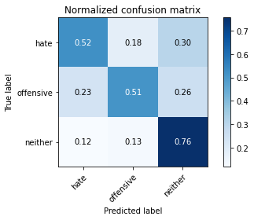

precision recall f1-score support

hate 0.52 0.52 0.52 773

offensive 0.34 0.51 0.41 430

neither 0.84 0.76 0.79 2329

accuracy 0.67 3532

macro avg 0.56 0.60 0.57 3532

weighted avg 0.71 0.67 0.69 3532

average eval_loss: 1.6114628485030373, accuracy: 0.6749716874292185

training 9 epoch...

26.49175786972046 seconds used......

9 training finished! average train loss: 0.013775805324257817

evaluating...

Confusion matrix, without normalization

[[ 378 123 272]

[ 105 199 126]

[ 270 194 1865]]

Normalized confusion matrix

[[0.48900388 0.15912031 0.35187581]

[0.24418605 0.4627907 0.29302326]

[0.11592958 0.08329755 0.80077286]]

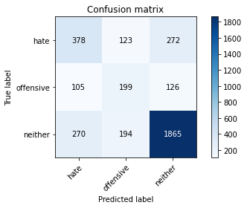

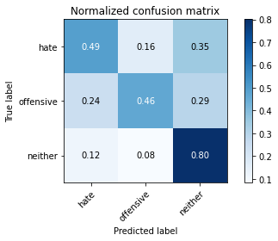

precision recall f1-score support

hate 0.50 0.49 0.50 773

offensive 0.39 0.46 0.42 430

neither 0.82 0.80 0.81 2329

accuracy 0.69 3532

macro avg 0.57 0.58 0.58 3532

weighted avg 0.70 0.69 0.70 3532

average eval_loss: 1.5231307100104747, accuracy: 0.6913929784824462

training 10 epoch...

26.466363191604614 seconds used......

10 training finished! average train loss: 0.02457485339083873

evaluating...

Confusion matrix, without normalization

[[ 374 116 283]

[ 94 194 142]

[ 224 191 1914]]

Normalized confusion matrix

[[0.48382924 0.15006468 0.36610608]

[0.21860465 0.45116279 0.33023256]

[0.09617862 0.08200945 0.82181194]]

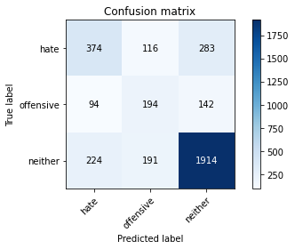

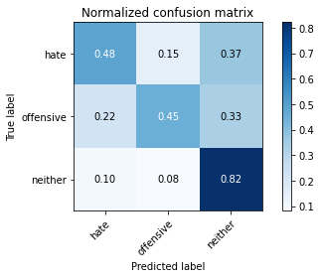

precision recall f1-score support

hate 0.54 0.48 0.51 773

offensive 0.39 0.45 0.42 430

neither 0.82 0.82 0.82 2329

accuracy 0.70 3532

macro avg 0.58 0.59 0.58 3532

weighted avg 0.71 0.70 0.70 3532

average eval_loss: 1.4341395788610318, accuracy: 0.702718006795017